Name: Sabau Andrei-Mircea, group 916

Conversion Calculator

  - arithmetic operations: addition, subtraction, multiplication and division by one digit, in a base p∈{2,3,...,9,10,16}
  - conversions of natural numbers between two bases p,q∈{2,3,...,9,10,16} using the substitution method or successive divisions and rapid conversions between two bases p,q∈{2, 4, 8, 16}.

Feature list

F1. Add a natural number with a one digit number in a specific base
F2. Subtract a natural number with a one digit number in a specific base
F3. Multiply a natural number with a one digit number in a specific base
F4. Divide a natural number with a one digit number in a specific base
F5. Convert a real number from base b into base h

Iterations
Iteration | Features
I1 | F1. Add a natural number with one digit number in a specific base  F2. Subtract a natural number with one digit number in a specific base  F3. Multiply a natural number with one digit number in a specific base  F4. Divide a natural number with one digit number in a specific base
I2 | F5. Convert a real number from base b into base h  1. Substitution method  2. Successive divisions and multiplications  3. Rapid conversions

Iteration 1
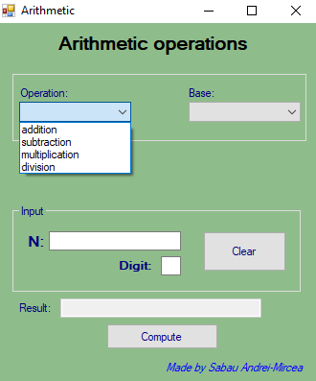

Iteration 2
